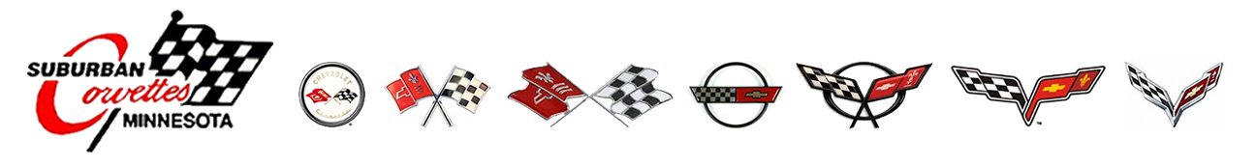
Suburban Corvettes of Minnesota invites car enthusiasts to drive and enjoy their favorite cars at the Brainerd International Raceway Competition track. Our experienced instructors are on hand to provide advice and guidance to both novice and experienced drivers, ensuring you make the most of your track time. Our community of friendly, talented drivers is always ready to share their experiences and help others develop their skills. Track days not only provide the thrill of high performance driving but also the opportunity to make friends, share experiences, and get advice. Our events offer approximately 2.5-3 hours of track time. Participating in BIR Drivers School and Track Days includes benefits such as in-car instruction for different driving levels, a well-organized event promoting safety, maximum track time, and post-event socializing. Our events are designed to accommodate most car makes and models, ensuring an inclusive, enjoyable experience for all.
WHAT YOU GET with LAPS TRACK DAYS HPDE/OPEN TRACK EVENTS (High Performance Drivers Education)
- 2.5-3 hours of track time (5 x 30 minute sessions or more)
- We welcome all driving experience levels - Beginner, intermediate, and advanced run groups. Drivers school available for drivers new to the track.
- In car Instruction available for Beginners, Intermediate and advanced driving levels
- Well run and organized event
- Easy going/low stress environment that's focused on safety, fun and driver advancement
- A structured schedule focused on getting the maximum track time allowable per event
- The most seat time for your dollar
- Social and fun group of like-minded enthusiasts
- Most makes and models welcome (some exceptions)
- Seat time, seat time, seat time!!!
- Registration opens March 1, 2025. Track dates are June 16, 2025 and September 15, 2025.Registration is available at msreg.com/SCM-BIR

